Heal Somerset
Appendix to Micro moth report 2023
By
Jenny Vickers
The following presents a list of macro moths and other taxa recorded on site while undertaking my micro moth survey work in 2023. All records have been/will be sent to the relevant recording scheme or iRecord.

Lepidoptera - Macro Moths
Timandra comae Blood-vein – adult daytime observation
Eilema griseola Dingy Footman – adult daytime observation
Allophyes oxyacanthae Green Brindled Crescent – LED moth trap
Griposia aprilina Merville du Jour – LED moth trap
Agrochola litura Brown-spot Pinion – LED moth trap
Agrochola lychnidis Beaded Chestnut – LED moth trap
Agrochola macilenta Yellow-line Quaker – LED moth trap
Conistra vaccinii Chestnut – LED moth trap
Conistra ligula Dark Chestnut – LED moth trap
Omphaloscelis lunosa Lunar Underwing – LED moth trap
Agrotis ipsilon Dark Sword-grass – LED moth trap

Lepidoptera - Butterflies
Thymelicus lineola Essex Skipper
Thymelicus sylvestris Small Skipper
Ochlodes sylvanus Large Skipper
Melanargia galathea Marbled White
Maniola jurtina Meadow Brown
Pyronia Tithonus Gatekeeper
Aphantopus hyperantus Ringlet
Vanessa Atalanta Red Admiral
Aglais urticae Small Tortoiseshell
Polygonia c-album Comma

Coleoptera - Beetles
Coccinella septempunctata 7-spot Ladybird
Propylea quattuordecimpunctata 14-spot Ladybird
Harmonia axyridis Harlequin Ladybird
Malachius bipustulatus Common Malachite
Oedemera nobilis Swollen-thighed Beetle
Grammoptera ruficornis Common Grammoptera
Pseudovadonia livida Fairy-ring Longhorn Beetle
Rhagonycha fulva Common Red Soldier Beetle
Gastrophysa viridula Green Dock Beetle
Lochmaea crataegi Hawthorn Leaf Beetle
Nicrophorus vespillo Common Burying Beetle
Crepidodera aurata Willow Flea Beetle

Diptera - Flies
Chrysogaster solstitialis Dark-winged Wrinkehead Hoverfly
Episyrphus balteatus Marmalade Hovefly
Myathropa florea Common Batman Hoverfly
Scaeva pyrastri White-bowed Smoothwing Hoverfly
Sphaerophora scripta Common Globetail Hoverfly
Melanostoma scalare Long-winged Duskyface Hoverfly
Platycheirus albimanus Grey-spotted Sedgesitter Hoverfly
Pyrophaena rosarum Fourspot Sedgesitter Hoverfly
Xanthogramma pedissequum Superb Dayglower Hoverfly
Syrphus ribesii Common Flower Hoverfly
Eristalis nemorum Stripe-faced Drone Fly
Eristalis tenax Common Drone Fly
Helophilus pendulus Tiger Marsh Hoverfly
Poecilobothrus nobilitatus A Long-legged Fly
Scathophaga stercoraria Yellow Dung-fly
Tephritis bardanae A Picture-winged Fly
Terellia tussilaginis A Picture-winged Fly
Xyphosia miliaria A Picture-winged Fly
Physocephala rufipes A Thick-headed Fly
Eriothrix rufomaculata A Parasitic Fly

Trichoptera - Caddisflies
Chaetopteryx villosa A Caddisfly

Psocoptera – Bark flies/lice
Valenzuela flavidus A Bark Fly

Hemiptera - Bugs
Coreus marginatus Dock Bug
Dolycoris baccarum Hairy Shieldbug
Palomena prasina Green Shieldbug
Pentatoma rufipes Red-legged Shieldbug
Eurydema oleracea Crucifer Shieldbug
Heterotoma planicornis A Plant Bug
Deraeocoris ruber A Plant Bug
Liocoris tripustulatus A Plant Bug
Stenodema laevigata A Plant Bug
Leptopterna dolabrata Meadow Plant Bug
Philaenus spumarius Common Froghopper

Hymenoptera – Bees, Wasps and Ants
Bombus lapidarius Large Red-tailed Bumblebee
Bombus pascuorum Common Carder Bumblebee
Platycampus luridiventris A Sawfly – larvae on Alnus glutinosa (Alder)

Odonata – Dragonflies and Damselflies
Sympetrum sanguineum Ruddy Darter
Sympetrum striolatum Common Darter
Aeshna cyanea Southern Hawker

Orthoptera – Grasshoppers and Bush-crickets
Conocephalus discolor Long-winged Cone-head
Conocephalus dorsalis Short-winged Cone-head
Pseudochorthippus parallelus Meadow Grasshopper
Metrioptera roeselii Roesel’s Bush-cricket
Leptophyes punctatissima Speckled Bush-cricket

Non Lepidoptera mines
Fenusa dohrnii Sawfly mine on Alnus glutinosa (Alder)
Profenusa pygmaea Sawfly mine on Quercus robur (Oak)
Agromyza nana Fly mine on Trifolium repens (White Clover)
Phytomyza conyzae Fly mine on Pulicaria dysenterica (Fleabane)
Heterarthrus wuestneii Sawfly mine on Acer campestre (Field Maple)
Rhamphus oxyacanthae Beetle mine on Crataegus monogyna (Hawthorn)
Phytomyza agromyzina Fly mine on Cornus sanguinea (Dogwood)
Chromatomyia periclymeni Fly mine on Lonicera periclymenum (Honeysuckle)

Galls
Acalitus brevitarsus Gall mite on Alnus glutinosa (Alder)
Aceria eriobia Gall mite on Acer campestre (Field Maple)
Aceria macrochela Gall mite on Acer campestre (Field Maple)
Aceria myriadeum Gall mite on Acer campestre (Field Maple)
Aceria nalepai Gall mite on Alnus glutinosa (Alder)
Eriophyes crataegi Gall mite on Crataegus monogyna (Hawthorn)
Eriophyes similis Gall mite on Prunus spinosa (Blackthorn)
Phyllocoptes goniothorax Gall mite on Crataegus monogyna (Hawthorn)
Andricus curvator Sexual generation of gall wasp on Quercus robur (Oak)
Andricus foecundatrix Asexual generation of gall wasp on Quercus robur (Oak)
Andricus kollari Asexual generation of gall wasp on Quercus robur (Oak)
Andricus lignicolus Asexual generation of gall wasp on Quercus robur (Oak)
Andricus quercuscalicis Asexual generation of gall wasp on Quercus robur (Oak)
Cynips longiventris Asexual generation of gall wasp on Quercus robur (Oak)
Cynips quercusfolii Asexual generation of gall wasp on Quercus robur (Oak)
Diplolepis rosae Gall wasp on Rosa canina (Dog Rose)
Dasineura crataegi Gall midge on Crataegus monogyna (Hawthorn)
Dasineura fraxini Gall midge on Fraxinus excelsior (Ash)
Dasineura pustulans Gall midge on Filipendula ulmaria (Meadowsweet)
Dasineura ulmaria Gall midge on Filipendula ulmaria (Meadowsweet)
Dasineura urticae Gall midge on Urtica dioica (Nettle)
Rondaniola bursaria Gall midge on Glechoma hederacea (Ground Ivy)
Urophora cardui Gall Fly on Cirsium arvense (Creeping Thistle)
Phragmidium mucronatum Fungal gall on Rosa canina (Dog Rose)
Phragmidium violaceum Fungal gall on Rubus fruticosus agg. (Bramble)
Taphrina alni Fungal gall on Alnus glutinosa (Alder)
Taphrina pruni Fungal gall on Prunus spinosa (Blackthorn)
Psyllopsis fraxini Psyllid gall on Fraxinus excelsior (Ash)
Puccinia glechomatis Rust fungus on Glechoma hederacea (Ground Ivy)

Arachnids – Spiders and Harvestmen
Araneus diadematus Garden Spider
PIsura mirabilis Nursery-wed Spider
Phalangium opilio Harvestman
Paroligolophus agrestis Harvestman

For interest here are some photos of species recorded on site in 2023.

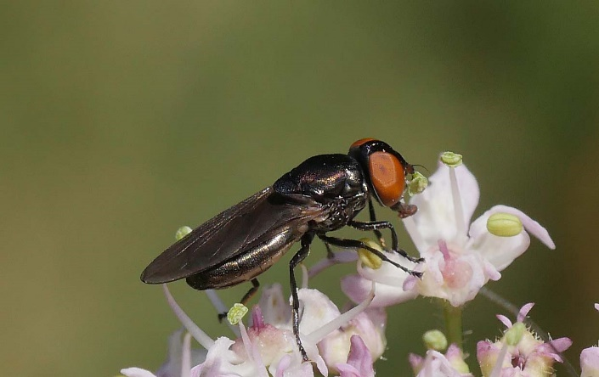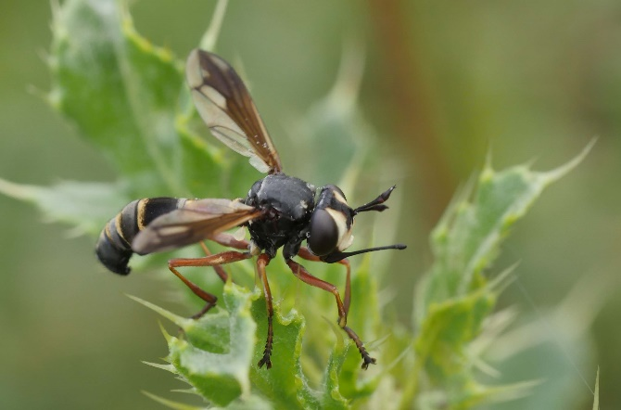
Chrysogaster solstitialis – female Physocephala rufipes

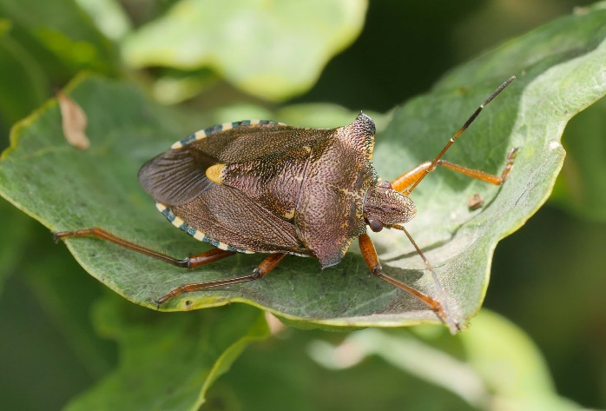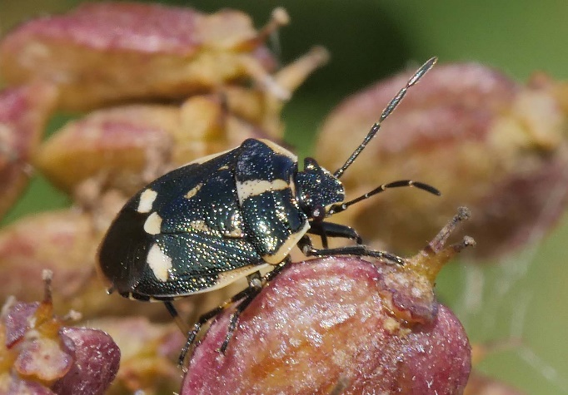
Pentatoma rufipes Eurydema oleracea

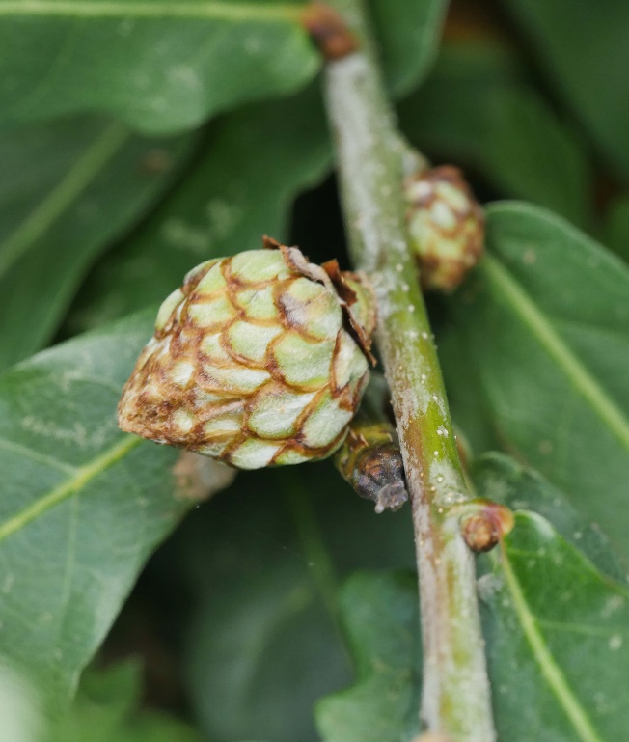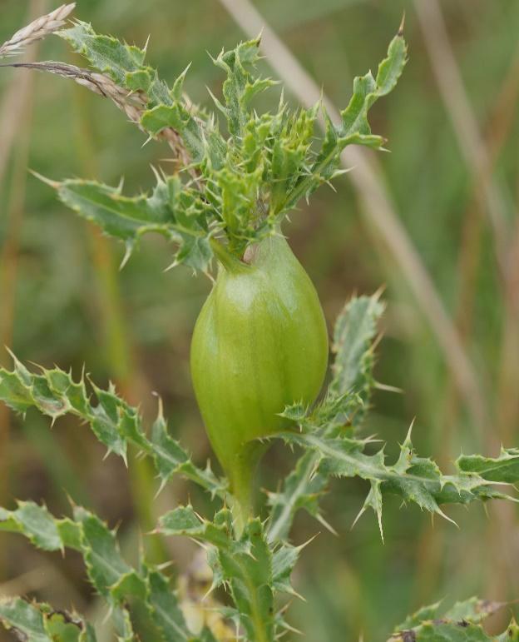
Andricus foecundatrix (Artichoke gall) Urophora cardui (A picture-winged Fly)

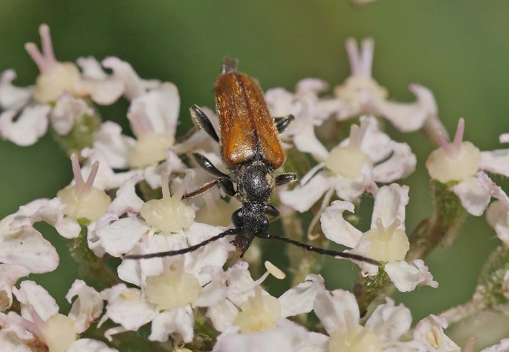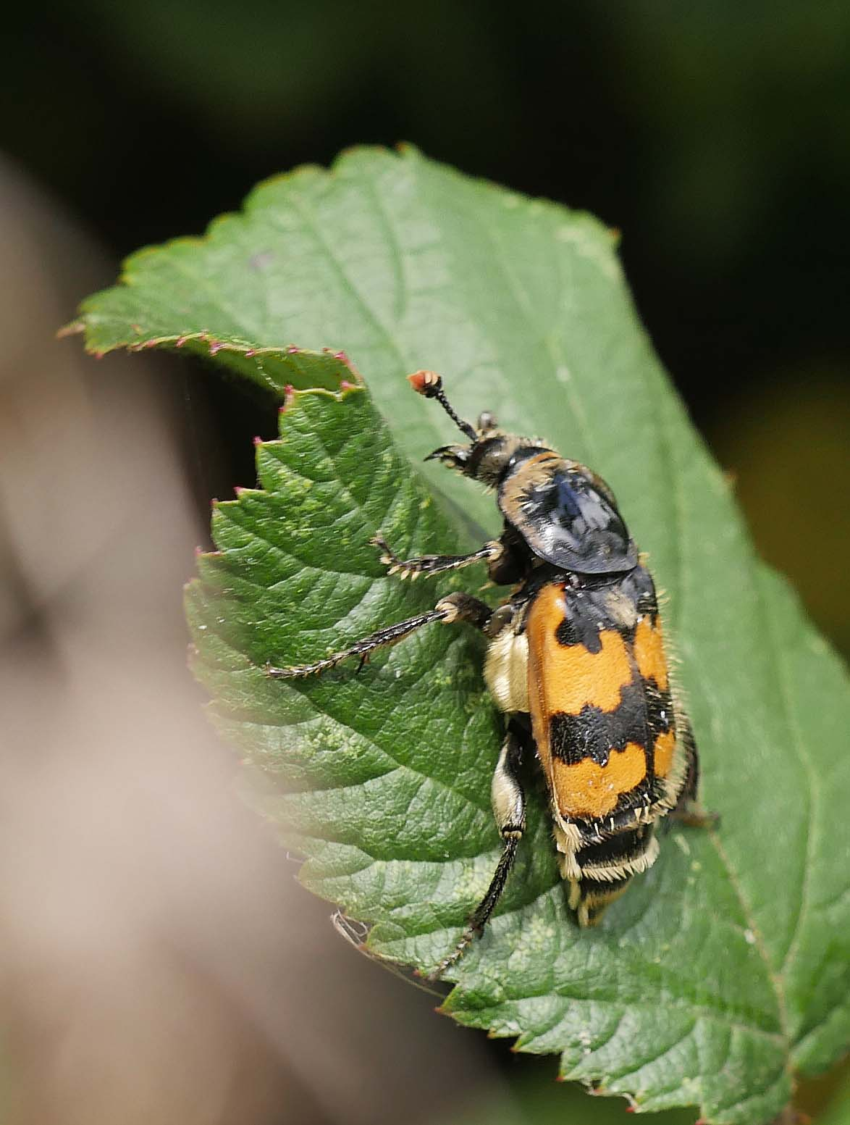
Pseudovadonia livida (Fairy-ring Longhorn) Nicrophorus vespillo (Common Burying Beetle

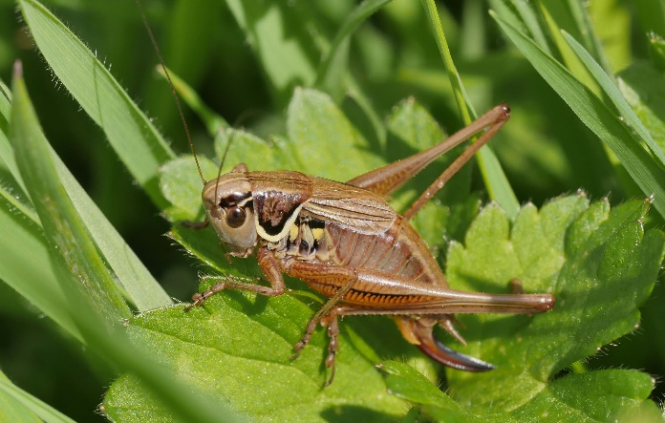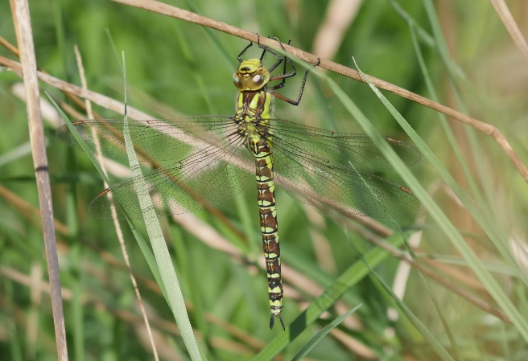
Metrioptera roeselii (Roesel’s Bush-cricket) Aeshna cyanea (Southern Hawker) female

